

Project Waterfall

**PROJECT PLAN**

FONTYS UNIVERSITY OF APPLIED SCIENCES

**HBO-ICT: English Stream**

|  |  |  |  |
| --- | --- | --- | --- |
| Data Student | | | |
| Family name, initials | Lekov, A. | Lalev, D | Yusufi, B |
| Student number | 3850900 | 3849511 | 3869709 |
| Project Leader | | | |
| Family name, initials | Balabanov, B | | |
| Student number | 3880133 | | |
| Client | | | |
| Client name | Media Bazaar | | |
| Company name | Jupiter | | |
| University tutor | | | |
| Family name, initials | Chung, K | | |
| Project Plan | | | |
| Title | Waterfall | | |
| Date | 02.13.2020 | | |
| Version | **0.2** | | |
| Approved and signed by university tutor | | | |
| Date |  | | |
| Name and signature university tutor |  | | |

Table of Contents

**INTRODUCTION** 4

**PROJECT STATEMENT** 5

Formal Client 5

Current Situation 5

Project Justification 5

**PROJECT OBJECTIVES** 6

Project Product 6

Project Approach 6

Project Deliverables and Non-Deliverables 7

Project Constraints 7

Project Risks 7

**PROJECT PHASING** 8

Phase 1: Analysis 8

Phase 2: Design 8

Phase 3 & 4: Implementation and Testing 8

Phase 5: Deployment 8

# INTRODUCTION

Dynamic Service, an IT team of four students, is hired by Media Bazaar (daughter company of Jupiter) to help them with administrative system. During this project, Dynamic Service will work eighteen weeks on a software solution for a hardware shop that establishes itself in the Netherlands.

The company Media Bazaar is planning to open their very first shop in Eindhoven. Administration is struggling with management of the company. The biggest challenge that Media Bazaar’s management foresees, is keeping track of their employees and products.

The IT students are looking forward to good collaboration, planning and communication between themselves in order to increase productivity. Communication with the tutor and the client will be crucial to the project’s success.

The final goal is to deliver a working application that will help the company fix its problems.

# PROJECT STATEMENT

## Formal Client

**Client: Media Bazaar**

 **Email client:** **s.vanhartingsveldt@fontys.nl**

**Contact Information:**

**Email project leader: 434236@student.fontys.nl**



**Email university tutor: c.kuah@fontys.nl**

## Current Situation

Media Bazaar is a newly opened store. Currently there are a lot of problems bringing chaos to the store. The company needs help and they think that a software solution would help them fix most of their problems. Firstly, they don’t have a real system that keeps track of the hired people, so managers don’t really know who is working for them. Also, employees don’t know themselves when they are supposed to work. Shelves in the store don’t get restocked because nobody is monitoring the purchases.

## Project Justification

There are problems present in the company Media Bazaar and the team is hired in order to deal with them by providing an IT solution.

# PROJECT OBJECTIVES

Our main objective is to deliver an application that will help Media Bazaar in solving the following problems:

* Managers don’t have a registry of fired people, a way to know why an employee has been fired or what is the reason for quitting.
* Managers can’t keep track of their employees. They don’t know who is really working for the company, when the employees are working.
* Managers can’t assign work shifts properly. They need something like calendar containing scheduled working hours. They do not want to be google calendar.
* Managers don’t have a clean view over attendance and work hours of their employees
* Managers don’t have a way to easily promote/demote a person
* Managers need a way to easily renew an employee’s working contract
* Employees don’t know when their work shifts start
* Shelves in store don’t get restocked because there is no system that tracks how much of the stock is left in the storage

* The company needs a database to store the credentials of its employees and information about their work (First name, last name, gender, birth date, birthplace, nationality, languages, BSN number, home address, FTI, work start date, work position, last day of work, how much work was actually done)

## Project Approach

In this project we will be using the “Waterfall” methodology where a project is completed in distinct stages and moved step by step toward final release to consumers. A big plan is made up front and then executed in a linear fashion, hoping there won’t be any changes in the plan.

## Project Deliverables and Non-Deliverables

**Deliverables**

* A Windows Forms Application connected to a Database, which resolves the problems specified above
* A project plans
* URS
* Process report
* Presentation of the product
* A website
* Agenda's and minutes of every meeting
* Test plan for our own project
* Test report for the other group’s system

**Non-Deliverables**

* A design document
* A user manual
* A Dutch version of the documentation

## Project Constraints

* There is a time limit of 6 weeks to complete the first part of the project
* Team must only consist of 4 members working on the project
* GIT must be used
* Program must be in English
* Program must be connected to a real Database

## Project Risks

The risks of the project are assessed below.

* Mid-project change in scope
* Technical inability for a given feature to be implemented
* Solution doesn’t meet the expectations of the client
* Being late with one of the steps will result in being late with the other ones
* Delivering something that the client doesn’t need

# PROJECT PHASING

Example: The project is divided into 5 phases, each phase resulting in different deliverables.

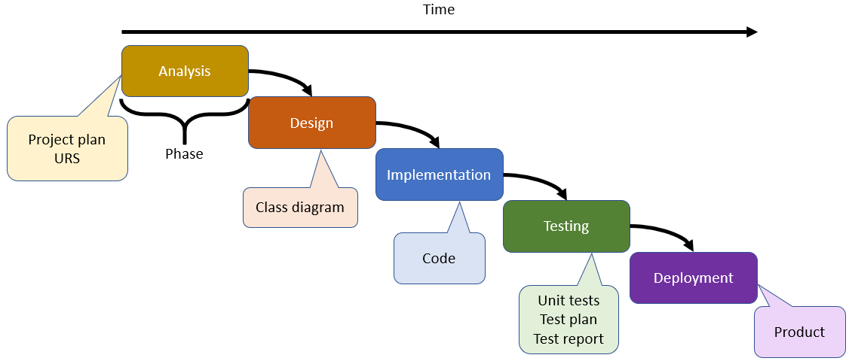

## Phase 1: Analysis (Week 1)

* Interview client (will be done in Week 1)
* Analyze problems (will be done in Week 1 and 2)
* Create workplan (first version of the document will be delivered by the end of week 1)

### Phase 2: Design (Week 2)

* Create GUI (first version will be created during week 2 and will be improved over time until week 6)
* Create URS (will be delivered in week 2)

### Phase 3 & 4: Implementation and Testing (Week 3,4,5)

* Implement software solution (an interim version will be ready in week 4 and it will be improved according to feedback received during testing)
* Test (will be done as soon as the project team has a interim version)

## Phase 5: Deployment (Week 6)

* Tag software as complete (software must be completed before the day of the final presentation)
* Present final version to client and peers (presentation will take place in week 6)